Juan Cardenas
Module 5.2 Assignment
bioSite Project
10/11/2026
I will be creating a simple website about my dad, Juan Emigdio Cardenas. The website will contain background information about his family values, personal interests, accomplishments, and future goals. The website will also include a biography and images to portray his story.
Interview Questions:
- What three words would you use to describe yourself?
Proactive, organized, and outgoing
- What brought you to California, and what was important about the years you spent there?
My parents and other siblings brought me to California in search of a better/brighter life.
- What do you remember about moving to Texas in 2007?
Moving to Texas was a very hard decision, but also very important as I saw it would be a better life and opportunity for my family.
- What is something you hope your four daughters and son learn from you?
I hope my kids learn from me “that nothing is given and hard work pays off at the end, with the satisfaction of seeing the accomplishment.”
- How did you get interested in running, and what do you enjoy about it?
After attending the 2nd half marathon my son and daughter ran, I noticed how many other older/younger and some people with disabilities were also participating, and I decided to join my son and daughter on their next run. I enjoy the challenge and being part of great events where I meet people that motivate me to sign up for the next event… “Oh, and I like that I can still somehow keep up with my son’s pace!”
- What inspired you to set a goal of completing the Los Angeles Marathon?
The challenge to train with effort and dedication.
- How are you planning to prepare for your first marathon, and what might be challenging?
I am preparing by sticking to the training plan (short runs/tempo runs/long runs), and the challenging part might be changing my eating habits and better hydration.
- How did you start officiating soccer games, and what do you like about it?
I started soccer officiating back in 2013 after stepping away from coaching my son’s soccer team. Some of the players I coached were doing it and they told me about it. I like the fact that I am still a part of the game I grew up playing and enjoy being able to mentor some of the kids/players while managing the game.
- What is your favorite way to spend a day when you are not running or officiating?
When not running or officiating, I enjoy being at home relaxing (grilling, going for a swim in the pool, and having a nice ice-cold adult beverage).
- What is one accomplishment or life moment you feel proud of?
I think my biggest accomplishment and life moment is seeing my kids all grown up, independent, and successful in their lives.

Biography:
Juan Emigdio Cardenas: A Story of Family, Dedication, and New Challenges
Born in Mexico on January 23, 1975, Juan Emigdio Cardenas is a proactive, organized, and outgoing individual whose life reflects the importance of family, hard work, and personal growth. At 51 years old, he continues to challenge himself, stay involved in activities he enjoys, and pursue new goals. His journey includes important family decisions, a lasting connection to soccer, and a newfound passion for running.
Juan's journey includes significant changes and decisions. His parents and siblings brought him to California in search of a better and brighter life. Later, in 2007, Juan made the difficult but important decision to move to Texas. He believed the move would provide a better life and more opportunities for his family. His experiences demonstrate how major life decisions often require courage, sacrifice, and a willingness to embrace change.
Family is central to Juan's definition of success. As a father of four daughters and one son, he hopes his children understand that accomplishments come through effort and persistence. He wants them to recognize that nothing is simply handed to them and that hard work brings the satisfaction of achieving something meaningful. One of his proudest accomplishments is seeing his children grow into independent and successful adults.
Juan has also maintained a strong connection to soccer. After stepping away from coaching his son's soccer team, he began officiating soccer games in 2013. People he had previously coached introduced him to officiating, giving him a way to remain involved in the sport he grew up playing. He enjoys managing games and mentoring young players while contributing to the sport that has remained important throughout his life.
More recently, Juan discovered a passion for running after attending his son and daughter’s half-marathon events. Seeing people of different ages and abilities participate inspired him to join them. He enjoys the challenge, the motivating atmosphere, and meeting people who encourage him to pursue additional events. He is also proud of being able to keep pace with his son!
Juan is now working toward another ambitious goal: completing the Los Angeles Marathon! His preparation includes following a training plan with short runs, tempo runs, and long runs. He recognizes that improving his eating habits and hydration may be challenging, but he is committed to the process. Through his family life, soccer officiating, and running, Juan continues to demonstrate that personal growth does not stop with age or experience. His story is one of dedication, family pride, and the determination to keep reaching for new goals.
Front-end Style Guide:
Juan Emigdio Cardenas

1: Color Palette
These five colors will be used consistently throughout the website.
Deep Navy  #1F3556 | Terracotta  #C66B4E | Muted Sage  #8A9B83 | Warm Cream  #F6F1E8 | Charcoal  #292929
Headings and navigation | Buttons and highlights | Secondary accents | Page backgrounds | Body text

2: Typography
MAIN HEADING · GEORGIA BOLD · 24 PT
A Story of Dedication
SECTION HEADING · GEORGIA BOLD · 18 PT
Family, Running, and Soccer
BODY TEXT · ARIAL · 12 PT
Juan's story reflects the importance of family, hard work, and the willingness to take on new challenges.
IMAGE CAPTION · ARIAL ITALIC · 10 PT
Running gives Juan a new goal to work toward.
- I will use Georgia font for headings, and Arial font will be used for paragraphs,
navigation, and captions.
3: Navigation and Links
JUAN CARDENAS Landing About Hobbies

The same navigation menu will appear on all three pages.
Explore His Story
Button style: terracotta background, white bold text, and consistent padding.
Example of an external link: ASICS Los Angeles Marathon
Links will be clearly identifiable and direct visitors to relevant outside resources.
4: Images and Layout
Consistent image display
Will use clear, appropriately sized personal photos of Juan with consistent spacing and short captions to make the website authentic.

Layout rules:
- Use generous space between sections.
- Align headings, paragraphs, and images consistently.
- Keep text easy to read against the background.
- Avoid overcrowding each page with too many elements.
5: Consistency Across Pages
The Landing page will introduce Juan, the About page will tell his life story, and the Hobbies page will focus on running and soccer officiating. All three pages will follow this guide's color, typography, navigation, image, and spacing rules.

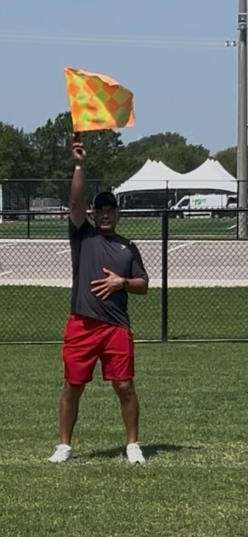
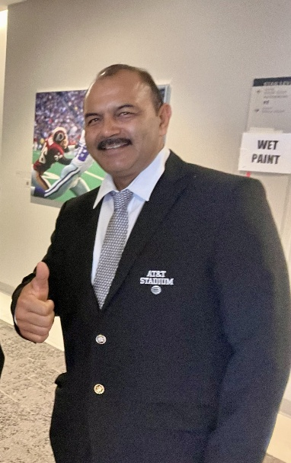
Images:
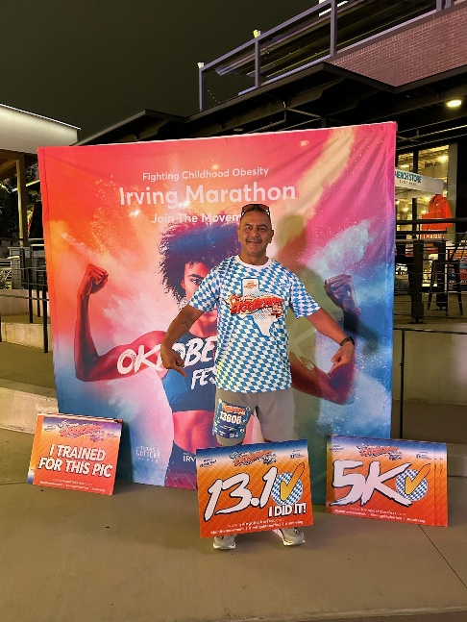
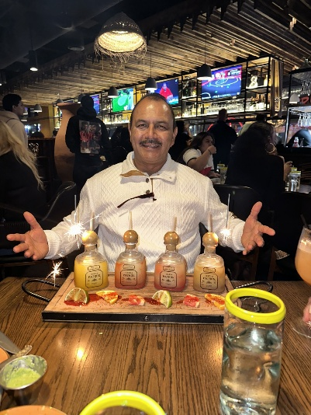
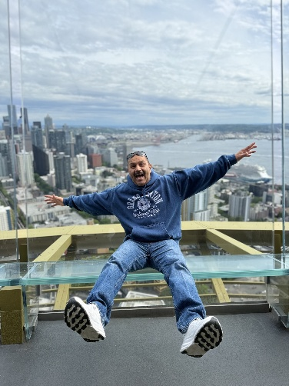
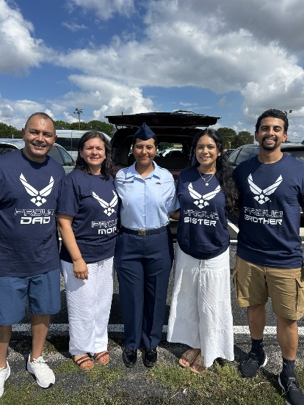
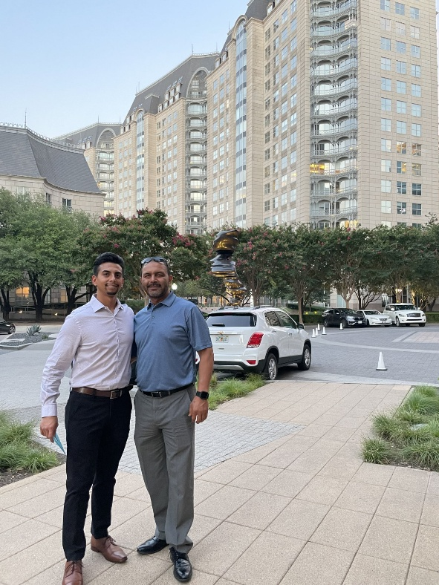
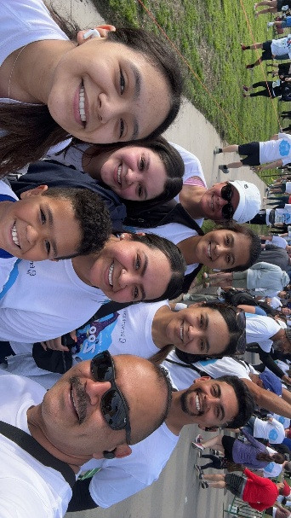
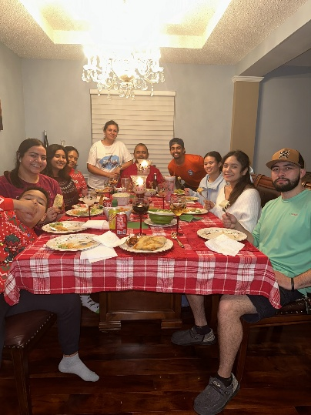
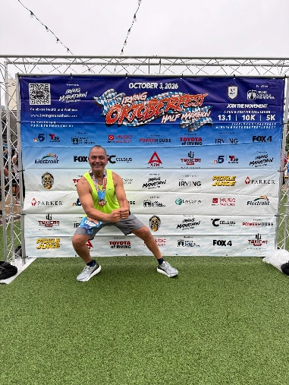
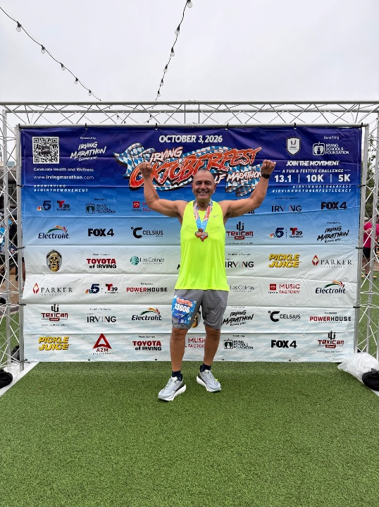
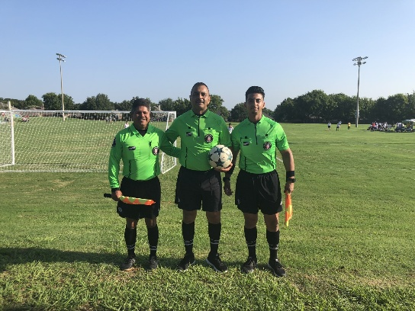
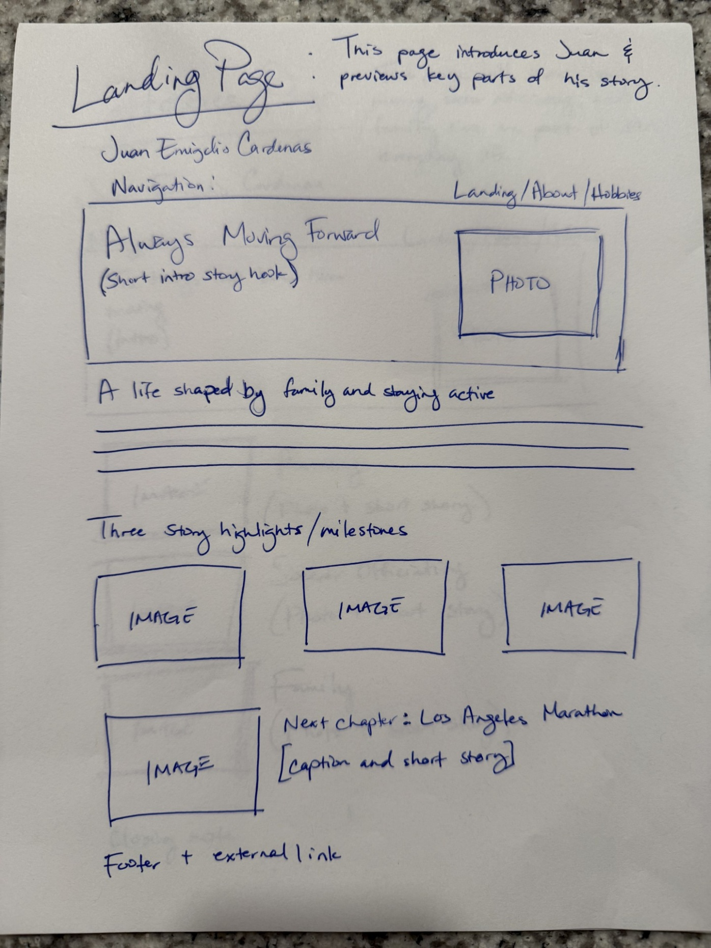
Wireframes:
